Infosys Springboard Virtual Internship 6.0

Unified Military Analytics and Comparison Dashboard – DV

Milestone Documentation

Module 4 & 5
(Dashboard Development and Integration)

By
Sivavardhini

1. Introduction
Milestone 3 focuses on the full development of interactive dashboards using Power BI.

After completing data scraping, cleaning, and KPI engineering, the cleaned dataset was imported into Power BI Desktop and used to build four fully integrated dashboards:

- Quick Stats
- Nation Overview
- Compare Powers
- Coalition Builder

These dashboards are connected using slicers, bookmarks, and DAX measures to ensure a seamless analytical experience.

2. Module 5 – Quick Stats and Nation Overview
2.1 Quick Stats Dashboard
- Objective
To provide a global-level overview of military strength across 140+ countries using dynamic KPIs and interactive filters.

Key Features Implemented
✔ Top 10 Countries by Power Index
- Bar chart sorted by Power Index score
- Automatically updates based on filters

✔ Dynamic KPI Cards
- Total Military Assets
- Total Active Personnel
- Combined Defense Budget
- Total Countries Included
All KPI values update dynamically based on slicer selections.

✔ Interactive Filters
- Region
- Continent
- Alliance (NATO / Non-NATO)
- Rank Range Slider
- Filters are applied globally and impact all visuals within the dashboard.
✔ Global Distribution Map
- Geographic visualization of military strength
- Country-level plotting using latitude and longitude

Output
The Quick Stats dashboard acts as an executive summary page for high-level insights and trend identification.

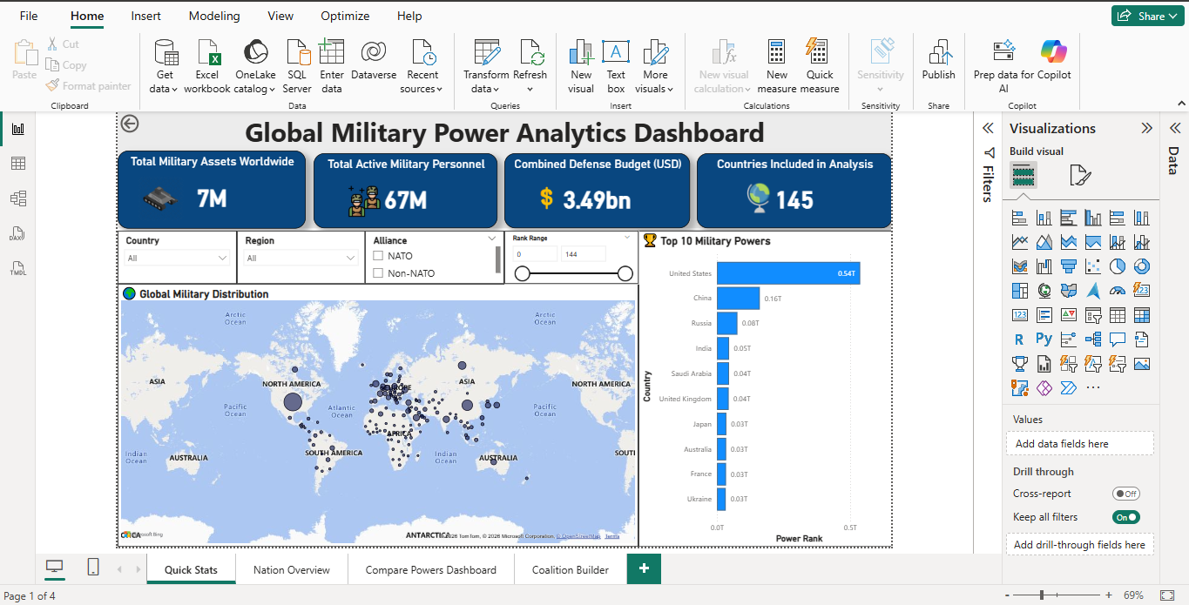
Figure 1: Quick Stats Dashboard – Global Military Overview

2.2 Nation Overview Dashboard
- Objective
To allow users to analyze the complete military profile of a selected country.

Features Implemented
✔ Country Selector (Dropdown Parameter)
- Users can select any country dynamically.

✔ Country-Level KPIs
- Power Index
- Global Rank
- Total Assets
- Active Personnel
- Assets per Capita

✔ Bar Chart – Military Composition
- Air Assets
- Tanks
- Naval Assets

✔ Pie Chart / Radar Chart
- Shows proportional distribution of assets

Outcome
This dashboard provides deep insight into individual country capability and composition.

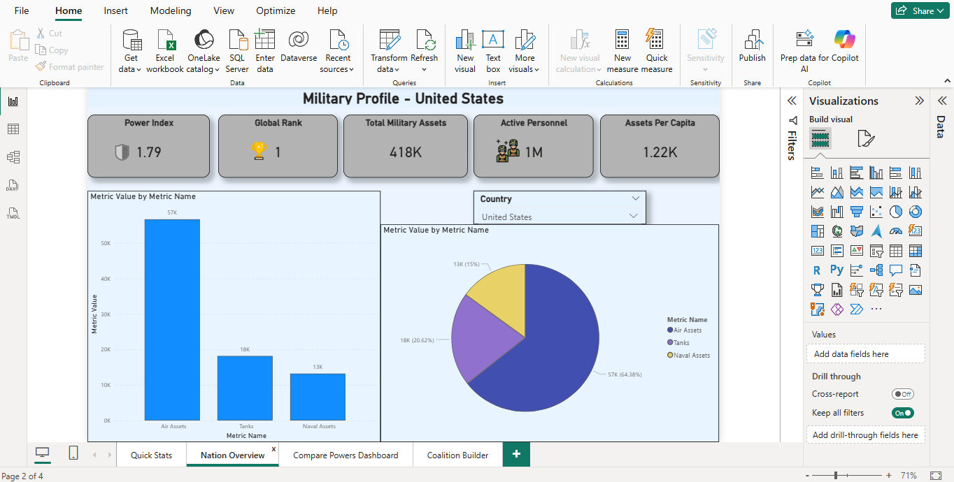
Figure 2: Nation Overview Dashboard – Country-Level Military Profile

3. Module 6 – Compare Powers and Coalition Builder
3.1 Compare Powers Dashboard
- Objective
To enable side-by-side comparison between any two countries.

Implementation Details
✔ Two Country Slicers
- Country 1 Selector
- Country 2 Selector
✔ DAX Measures for Comparison
Used CALCULATE() to filter metrics separately for each country.

✔ Comparison KPIs
- Active Personnel
- Defense Budget
- Power Index
- Total Assets
✔ Clustered Bar Chart
Compares:
- Active Personnel
- Reserve Personnel
- Total Assets
✔ Budget Comparison Chart
- Visual comparison of defense spending
Interaction Logic
Parameter actions dynamically update:
- Charts
- KPIs
- Comparison visuals

Outcome
Users can instantly analyze differences in manpower, assets, and economic military strength between two nations.

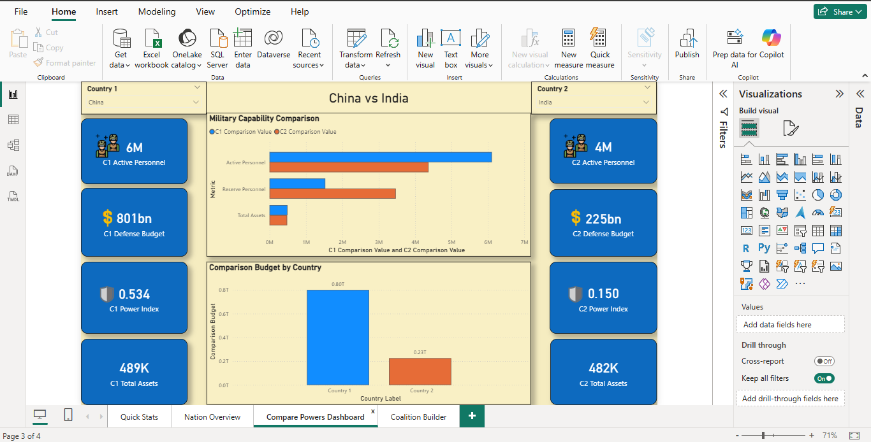
Figure 3: Compare Powers Dashboard – Side-by-Side Country Analysis

3.2 Coalition Builder Dashboard
Objective
To simulate alliance strength by combining multiple countries and comparing them to a reference nation.

Features Implemented
✔ Multi-Country Selection
- Users can select multiple coalition members

✔ Aggregated Metrics
- Coalition Active Personnel
- Coalition Aircraft
- Coalition Naval Assets
- Coalition Defense Budget

✔ Reference Country Selector
- Allows comparison against a single nation

✔ Comparison Chart
- Coalition totals vs Reference Country

✔ Budget Share Pie Chart
- Displays contribution percentage of each coalition member

Outcome
This dashboard enables strategic military alliance simulation and combined capability analysis.

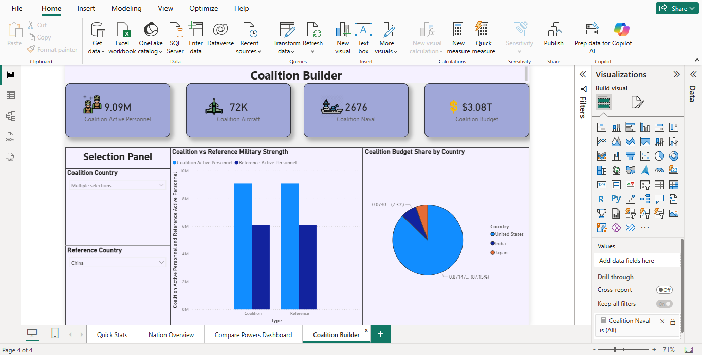
Figure 4: Coalition Builder Dashboard – Alliance Strength Simulation

4. Dashboard Integration in Power BI
The following integration mechanisms were implemented:
✔ Linked filters across dashboards
✔ Parameter actions for seamless transitions
✔ Consistent design theme across all tabs
✔ Dynamic updating of KPIs and visuals
This ensures a unified user experience across all modules.

5. Deliverables
Final Power BI file:
global_military_firepower_2025.pbix
Four fully integrated dashboards:
- Quick Stats
- Nation Overview
- Compare Powers
- Coalition Builder

- Deliverables
✔ Filters work correctly across all dashboards
✔ Parameters dynamically update comparisons
✔ Coalition aggregation functions correctly
✔ All KPIs correctly displayed
Milestone 3 successfully completes full dashboard development and integration.

